ASSIGNMENT – 7

Om Gupta 214047

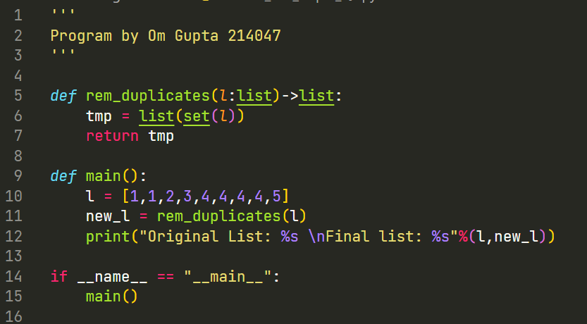Question 1:



Output 1:

Question 2:

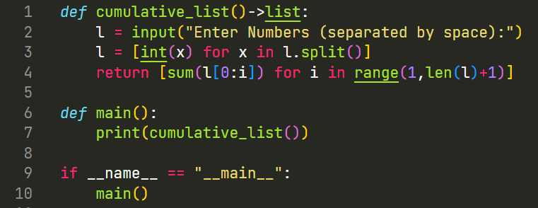



Output 2:

Question 3:

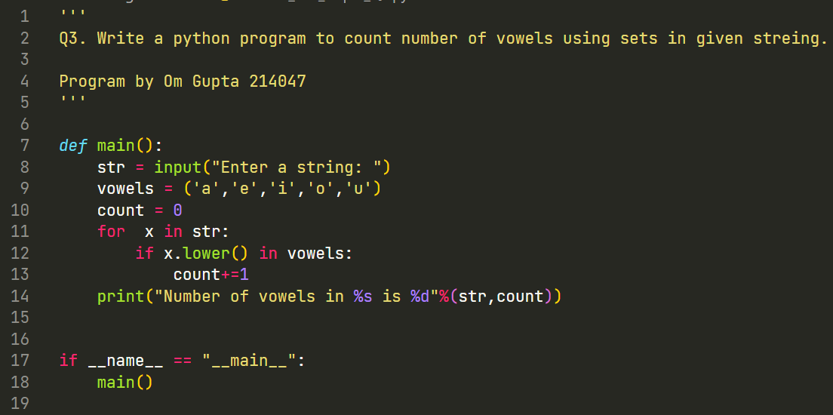

Output 3: